A **work breakdown structure (WBS)**, in [project management](http://en.wikipedia.org/wiki/Project_management) and [systems engineering](http://en.wikipedia.org/wiki/Systems_engineering), is a deliverable oriented decomposition of a project into smaller components.A work breakdown structure element may be a [product](http://en.wikipedia.org/wiki/Product_%28business%29), [data](http://en.wikipedia.org/wiki/Data), [service](http://en.wikipedia.org/wiki/Service_%28economics%29), or any combination thereof. A WBS also provides the necessary framework for detailed cost estimating and control along with providing guidance for schedule development and control.Same as decomposition in Function oriented design.

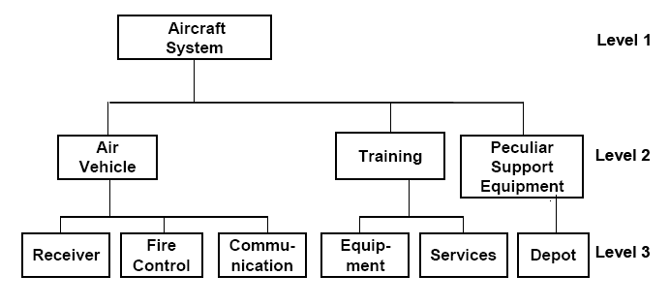

https://mail.google.com/mail/u/0/images/cleardot.gif